Software design
MiniShop FastFood System
Version 1.0
Prepared by class PRN211_E4, Group 5
Chu Đình Việt - HE153298
Dương Quốc Trung - HE153392
Vũ Việt Hoàng - HE161227

Contents
Revision history 4
1. Document description 5
2. SRS overview 5
2.1. List of system users 5
2.2. List of use cases 5
2.3. Use case diagram 6
2.3.1. Preliminary use case diagram 6
2.3.2. Use case detail diagrams 6
2.3.2.1. Use case “Manage Information” 6
2.3.2.2. Use case “Manage Menu” 6
2.3.2.3. Use case “Manage Employee” 6
2.3.2.4. Use case “Manage Table” 6
2.3.2.5. Use case “Manage Revenue” 6
2.3.2.5. Use case “Manage Order” 6
2.4. Activity diagrams of use case scenarios 8
2.4.1. Activity diagram for use case “” 8
2.4.2. Activity diagram for use case “” 9
2.4.3. Activity diagram for use case “” 10
3. Data model 11
3.1. Entity Relationship Diagram 11
3.1.2 Class Diagram 11
3.2. Table details/Chi tiết các bảng 11
3.2.1. Table name: Table 11
3.2.2. Table name: Bill 11
3.2.3. Table name: Food 11
3.2.4. Table name: Option 12
3.2.5. Table name: Category 12
3.2.6. Table name: User 12
3.2.7. Table name: Bill Detail 13

Revision history
Date | Authors | Modifications | Version

Document description
This document describes OO solution version 1.0 for Minishop system. It is divided into the following sections:

- In the section 2 an overview of the Minishop system’s requirements will be provided, including list of system users, use cases, use case diagram, and activity diagrams that describes the most important use case scenarios.
- In the section 3 an E-R diagram and all tables of the Minishop system in detail will be presented.

SRS overview

2.1. List of system users
1. Manager: The person who can manage employees, revenue, products, and customers
2. Employee: Product and order managers
2. Customer: The person who can order and use the product

2.2. List of use cases
1. Manage information (Dương Quốc Trung)
2. Manage Menu (Chu Đình Việt)
3. Manage Table (Dương Quốc Trung)
4. Manage employee (Chu Đình Việt)
5. Manage Revenue(Vũ Việt Hoàng)
6. Order(Vũ Việt Hoàng)

2.3. Use case diagram

2.3.1. Preliminary use case diagram
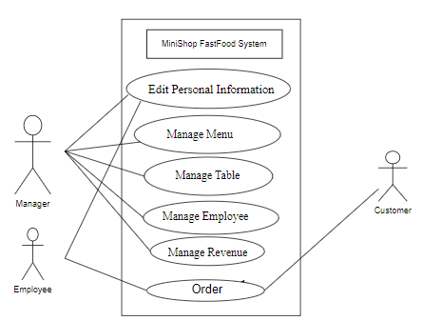

2.3.2. Use case detail diagrams

2.3.2.1. Use case “Manage Information”

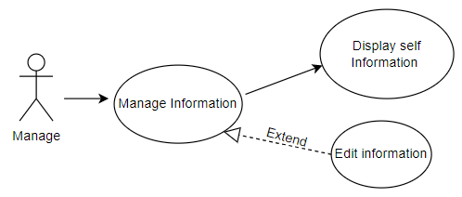

2.3.2.2. Use case “Manage MENU”
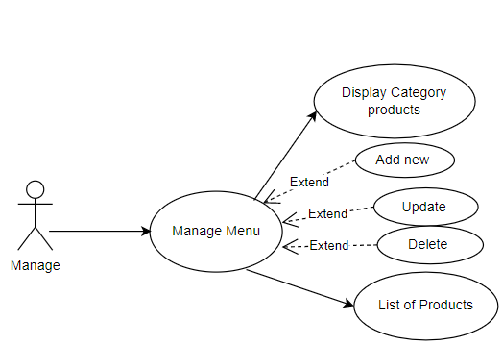

2.3.2.3. Use case “Manage Employee”
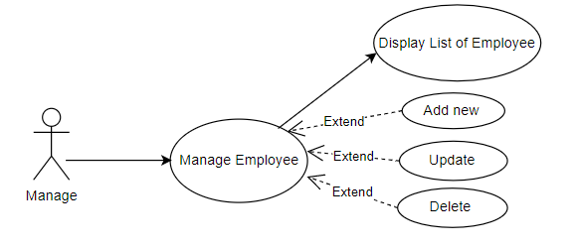

2.3.2.4. Use case “Manage Table”
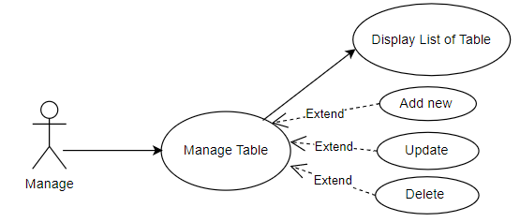

2.3.2.5. Use case “Manage Revenue”
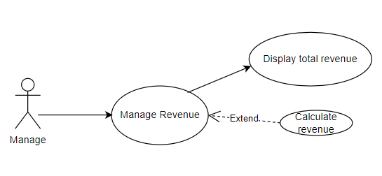

2.3.2.6. Use case “Order”
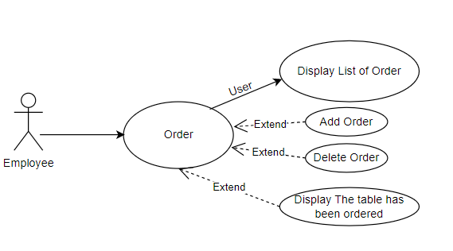

2.4. Activity diagrams of use case scenarios
Activity diagram
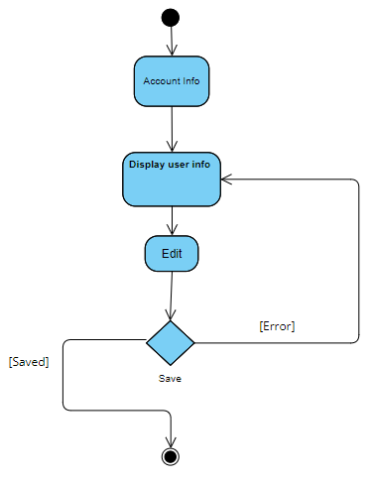
2.4.3 UC-2 Manage Menu
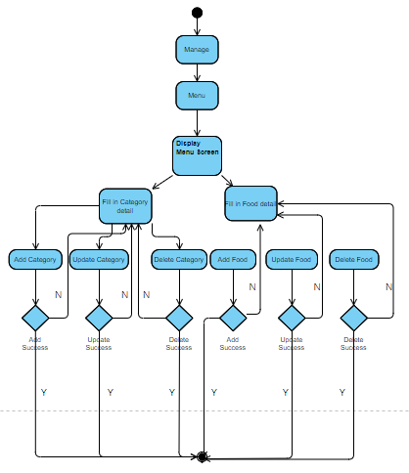
*N : Returns with an error message.
2.3.3 UC-3 Manage Employee

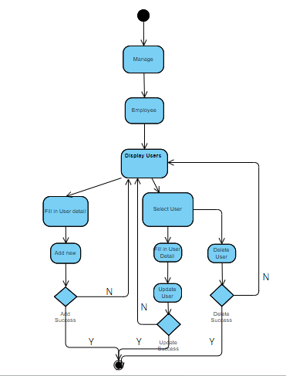
2.3.4 UC-4 Manage Table

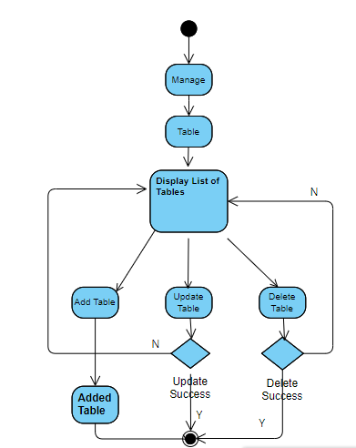
2.3.5 UC-5 Manage Revenue

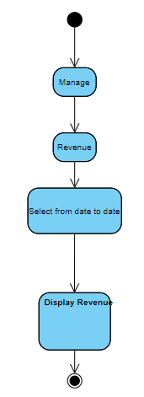

2.3.6 UC-6 Order
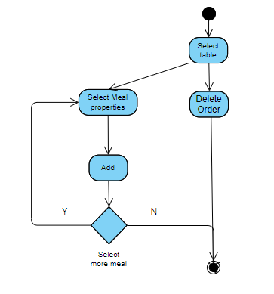

Activity Diagram
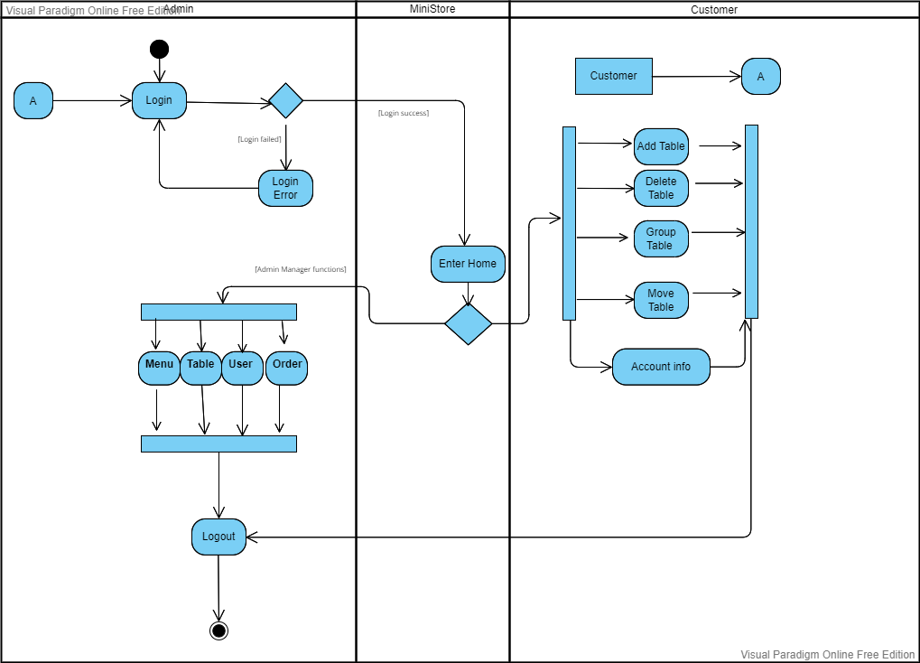

3. Data model
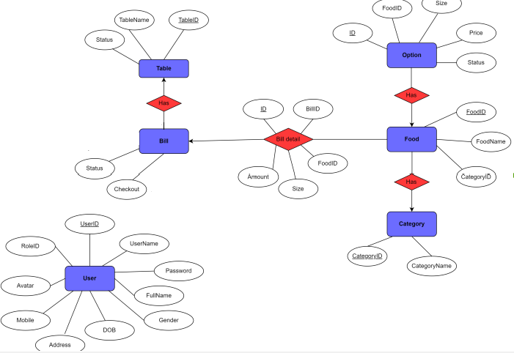
Entity Relationship Diagram

3.1.2. Class Diagram
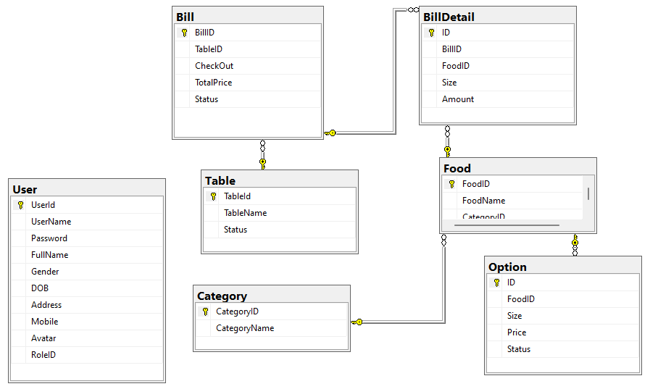

Table detail
Table : User
Field Name | Type | Size | Note
UserID | int |  | Primary key
UserName | nvarchar | 30 | Allow null
Password | nvarchar | 30 | Allow null
FullName | nvarchar | 30 | Allow null
Gender | bit |  | Allow null
DOB | smalldatetime |  | Allow null
Address | nvarchar | 100 | Allow null
Mobile | nvarchar | 10 | Allow null
Avatar | nvarchar | max | Allow null
RoleID | bit |  | Allow null

Table : Category

Field Name | Type | Size | Note
CategoryID | int |  | Primary Key
CategoryName | nvarchar | 40 | Allow null

Table : Table
Field Name | Type | Size | Note
TableID | int |  | Primary Key
TableName | nvarchar | 10 | Allow null
Status | bit |  | Allow null

Table : Food
Field Name | Type | Size | Note
FoodID | int |  | Primary Key
FoodName | nvarchar | 100 | Allow null
CategoryID | int |  | Allow null

Table : Option
Field Name | Type | Size | Note
ID | int |  | Primary Key
FoodID | int |  | Not null
Size | char |  | Allow null
Price | int |  | Allow null
Status | bit |  | Allow null

Table : Bill
Field Name | Type | Size | Note
BillID | int |  | Primary Key
TableID | int |  | Allow null
CheckOut | smalldatetime |  | Allow null
TotalPrice | nvarchar | 50 | Allow null
Status | bit |  | Allow null

Table : BillDetail
Field Name | Type | Size | Note
ID | int |  | Primary Key
BillID | int |  | Not null
FoodID | int |  | Allow null
Size | char | 1 | Allow null
Amount | tinyint |  | Allow null

4. Display
4.1. Login Fail
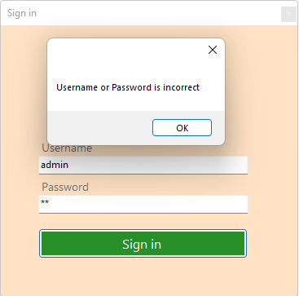

4.2.2. Display Employee Role
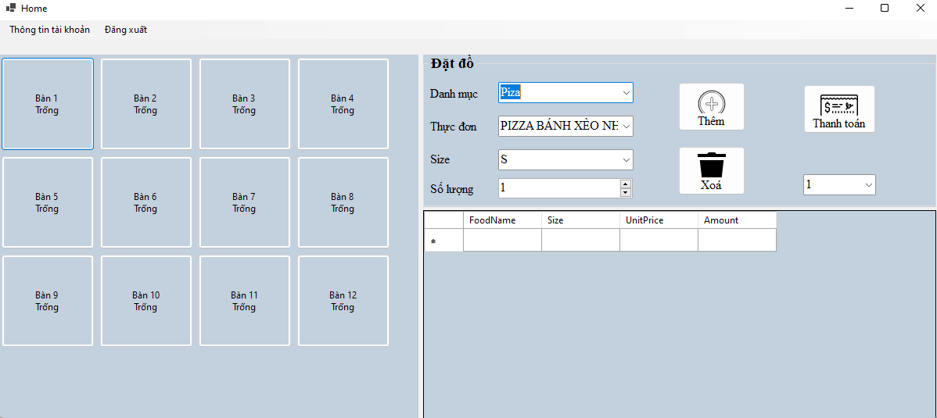
4.2.3. Display Manager Role
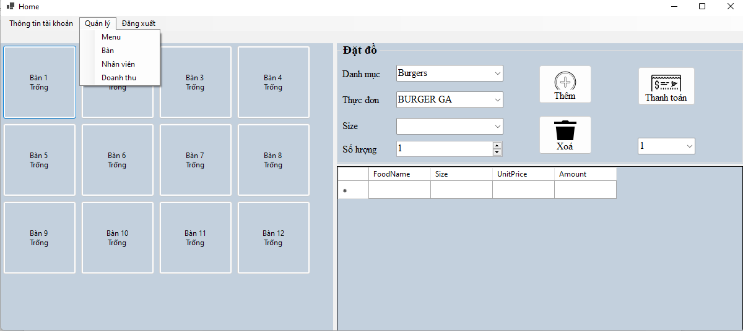
4.2.4. Manage Information
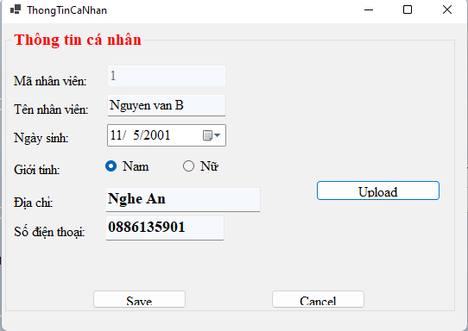

4.2.5.Manage Menu
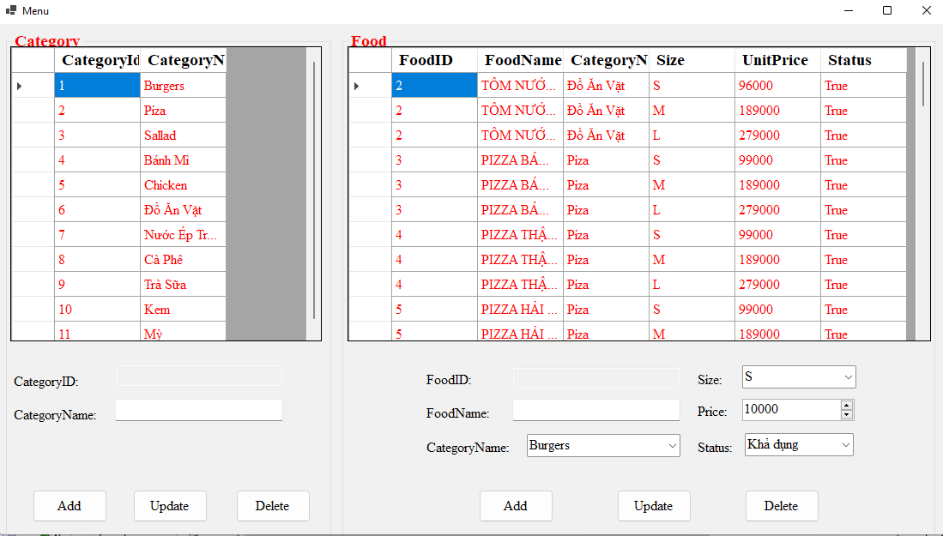

4.2.6. Manage Table
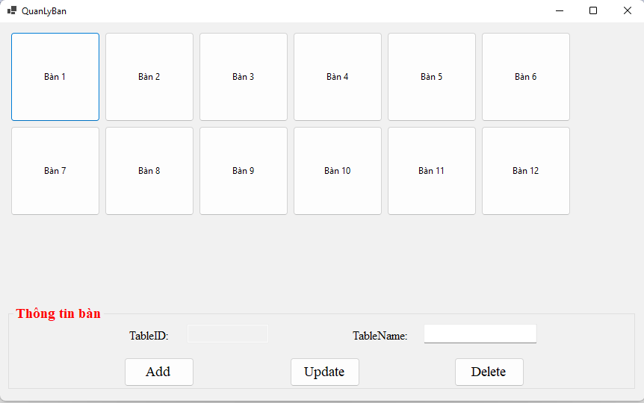
4.2.7.Display Employee
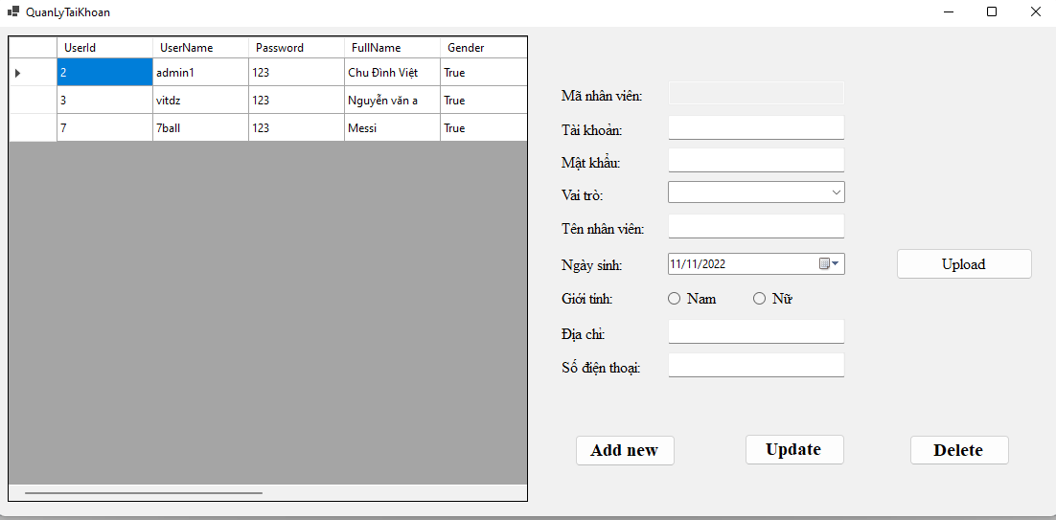
4.2.8.Manage Revenue
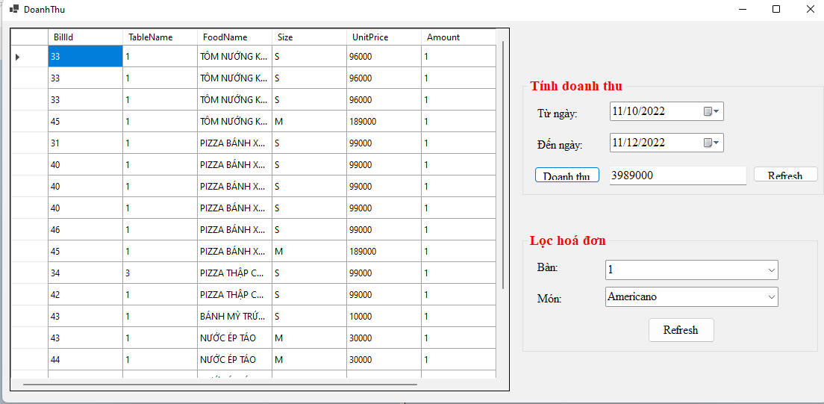
4.2.9. Order
